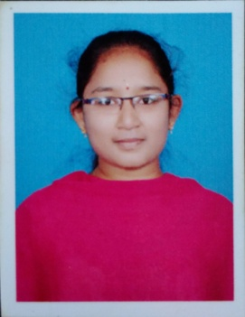 Resume

Poojitha Muthineni

D:NO::1-153-2,

BRAMHANAPALLI,

RAJAMPET,

EMAIL: muthinenipoojitha1996@gmail.com,

Ph No: 8106354504.

**Objective:**

Looking to take up a challenging position in a reputed organization that will enable me to use my strong organizational skills, award winning educational background and ability to work well with people.

**Experience**: Worked as DTT in Saint Gobain Crystals and Detectors Pvt ltd

Job responsibilities:

* Dealing with Meyer Berger multi wire saw machine
* Dealing with CNC vertical milling machine
* Also dealing with conventional milling machine
* Also I will deal with the data of the all process and material required for the process.

JOD: July 26, 2018

**Education:**

* Completed **B.Tech(Mech)** in the year of 2018 with aggregate of **71%** from JNTUA college of engineering ,kalikiri
* Completed my **Diploma** in the year of march 2015 with **82%** from government polytechnic college Rajampet.
* Persuade **S.S.C** in the march 2012 with 7.7 GPA from Regency nalanda school.

**Technical skills**:

* M.S Office
* Auto CAD
* ProgeCAD
* Basics of CATIA

**Areas of interest**:

* Interested in Production, Manufacturing and development departments.
* Also interested in software department related to Mechanical Engineering.

**Strengths:**

* Quickly Grasping.
* Hardworking and dedicated towards achieving the Goals and Objectives.
* Interested in learning new technologies.

**Project details**:

A Novel Hybrid Mechanism by adding additional wheel to an automobile.

**Personnel profile:**

* Name - M.Poojitha
* Father name - M.Krishna
* Date of Birth - 14/08/1996
* Marital status - unmarried
* Gender - Female
* Nationality - Indian
* Languages known - English, Hindi,Telugu

**Declaration:**

I hereby declare that the details furnished above are true and correct to the best of my knowledge.

Place**:**

Date:

(M.Poojitha)